1. Quản lý phân quyền người dùng

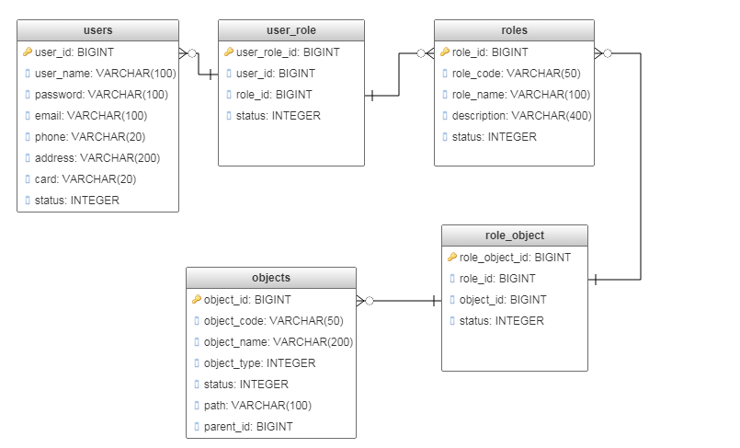

# Create tables

CREATE TABLE IF NOT EXISTS users

(

user_id BIGINT NOT NULL,

user_name VARCHAR(100),

password VARCHAR(100),

email VARCHAR(100),

phone VARCHAR(20),

address VARCHAR(200),

card VARCHAR(20),

status INT DEFAULT 1,

PRIMARY KEY(user_id)

);

CREATE TABLE IF NOT EXISTS roles

(

role_id BIGINT NOT NULL,

role_code VARCHAR(50),

role_name VARCHAR(100),

description VARCHAR(400),

status INT DEFAULT 1,

PRIMARY KEY(role_id)

);

CREATE TABLE IF NOT EXISTS objects

(

object_id BIGINT NOT NULL,

object_code VARCHAR(50),

object_name VARCHAR(200),

object_type INT,

status INT DEFAULT 1,

path VARCHAR(100),

parent_id BIGINT,

PRIMARY KEY(object_id)

);

CREATE TABLE IF NOT EXISTS role_object

(

role_object_id BIGINT NOT NULL,

role_id BIGINT,

object_id BIGINT,

status INT DEFAULT 1,

PRIMARY KEY(role_object_id)

);

CREATE TABLE IF NOT EXISTS user_role

(

user_role_id BIGINT NOT NULL,

user_id BIGINT,

role_id BIGINT,

status INT DEFAULT 1,

PRIMARY KEY(user_role_id)

);Nghiệp vụ hệ thống kinh doanh CKP

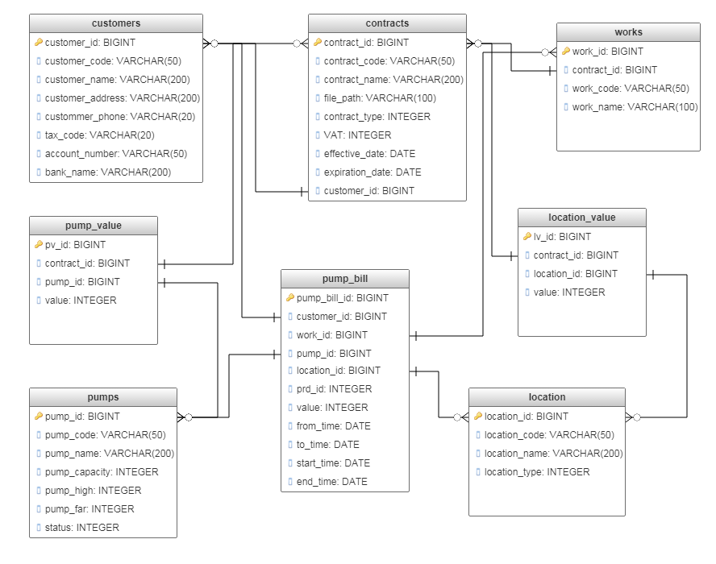

# Create tables

CREATE TABLE IF NOT EXISTS customers

(

customer_id BIGINT NOT NULL,

customer_code VARCHAR(50),

customer_name VARCHAR(200),

customer_address VARCHAR(200),

custommer_phone VARCHAR(20),

tax_code VARCHAR(20),

account_number VARCHAR(50),

bank_name VARCHAR(200),

PRIMARY KEY(customer_id)

);

CREATE TABLE IF NOT EXISTS pump_value

(

pv_id BIGINT NOT NULL,

contract_id BIGINT,

pump_id BIGINT,

value INT,

PRIMARY KEY(pv_id)

);

CREATE TABLE IF NOT EXISTS contracts

(

contract_id BIGINT NOT NULL,

contract_code VARCHAR(50),

contract_name VARCHAR(200),

file_path VARCHAR(100),

contract_type INT,

VAT INT,

effective_date DATE,

expiration_date DATE,

customer_id BIGINT,

PRIMARY KEY(contract_id)

);

CREATE TABLE IF NOT EXISTS location_value

(

lv_id BIGINT NOT NULL,

contract_id BIGINT,

location_id BIGINT,

value INT,

PRIMARY KEY(lv_id)

);

CREATE TABLE IF NOT EXISTS works

(

work_id BIGINT NOT NULL,

contract_id BIGINT NOT NULL,

work_code VARCHAR(50),

work_name VARCHAR(100),

PRIMARY KEY(work_id)

);

CREATE TABLE IF NOT EXISTS pumps

(

pump_id BIGINT NOT NULL,

pump_code VARCHAR(50),

pump_name VARCHAR(200),

pump_capacity INT,

pump_high INT,

pump_far INT,

status INT DEFAULT 1,

PRIMARY KEY(pump_id)

);

CREATE TABLE IF NOT EXISTS location

(

location_id BIGINT NOT NULL,

location_code VARCHAR(50),

location_name VARCHAR(200),

location_type INT,

PRIMARY KEY(location_id)

);

CREATE TABLE IF NOT EXISTS pump_bill

(

pump_bill_id BIGINT NOT NULL,

customer_id BIGINT,

work_id BIGINT,

pump_id BIGINT,

location_id BIGINT,

prd_id INT,

value INT,

from_time DATE,

to_time DATE,

start_time DATE,

end_time DATE,

PRIMARY KEY(pump_bill_id)

);